**CS 5551 Second Increment Report** Adam Carter

Class ID: 9, Project Group ID: 1

CS 5591 – Spring 2015

1. **Introduction**

This is the summary report of the second iteration of work performed on the Terrapin Collection Manager system. This system proposes to implement a framework for organizing and managing a user’s Board Game collection. The full background of this project can be found in the Project Proposal Document [1] submitted previously.

For this second iteration, my primary focus to begin the iteration was on the agent process and improving the process for fetching and then approving game content. While not complete, this process took longer than expected due to a high degree of variation and inconsistency in the data. Focus then shifted to the Services tier, where User and Collection services were implemented. Finally, the last few days involved finally performing some front end work and creating an initial set of web pages.

Since many of the details behind the architecture of this system were discussed previously in my Project Plan [2] and elaborated on during the First Iteration [3], I will not be repeating elements of those discussions here except to discuss changes or additions.

1. **Objectives**

The objectives of this iteration, given where last iteration ended, were to solidify the external data pull operations, prepare that data to be analyzed and converted into Game objects, then associated the other external sources via matching to the Game.

Roughly the first half of this iteration was devoted to this process, with most of the code changes coming in the Agent layer, supported by corresponding changes to the ac-games-pojos project as new issues were discovered. To put some numbers into perspective:

Total number of Games listed on BoardGameGeek I am tracking: 158536

Total number of Vendor entries I am tracking: 146429

Because of the scope, I spent a fair amount of time working on building some intelligence into the processing effort, determining which entries were invalid or incomplete, which items are capable of being ignored (for example, entries for game supplies instead of games), and attempting to automatically process and confirm as many entries as possible. This effort is still in flight, but so far I have been able to review more than 93% of BoardGameGeek entries and developed a means of categorizing Vendor data that should help during the automated matching work.

Since some of that work can only be done manually, I turned my attention to the UI, rather than try to do all that work by hand. However, prior to being able to work on that interface, I realized I needed to build out the services to support not just Game and GameReltn data, but also Users to support login and permissions, which then led to the need to implement Collection data to complete the User object and it’s child classes. Most of the second half of this iteration was spent building out the required REST service endpoints, which will be discussed later.

Finally, the last four days I have been finally diving into HTML5 and Bootstrap to work on developing a UI. I was able to create a home page, about page, and login and signup pages to move forward, but those pages allowed me to learn a lot more about HTML5 and Bootstrap in particular. This time will be very valuable moving forward in the remaining iterations.

1. **Design Overview**

Fundamentally, there have been no significant changes to the overall architecture of the system. This iteration was really more about expanding capabilities than exploring design issues, with the exception perhaps of the web pages. Much of the planning on how new services should be implemented has been done previously.

One change I did make was to change the structure of my web pages to move away from a single page model where multiple pages are specified as page content in the HTML body and instead created separate HTML pages for each required page. There were issues I encountered related to how the page separation was being handled (or not handled). This forced me to consolidate libraries, generating a single common .css file for all related pages, and has resulted in some level of duplicated code, but has the tradeoff of being cleaner to manage events and reduced page load times due to javascript tasks that are required in some instances to run at page load.

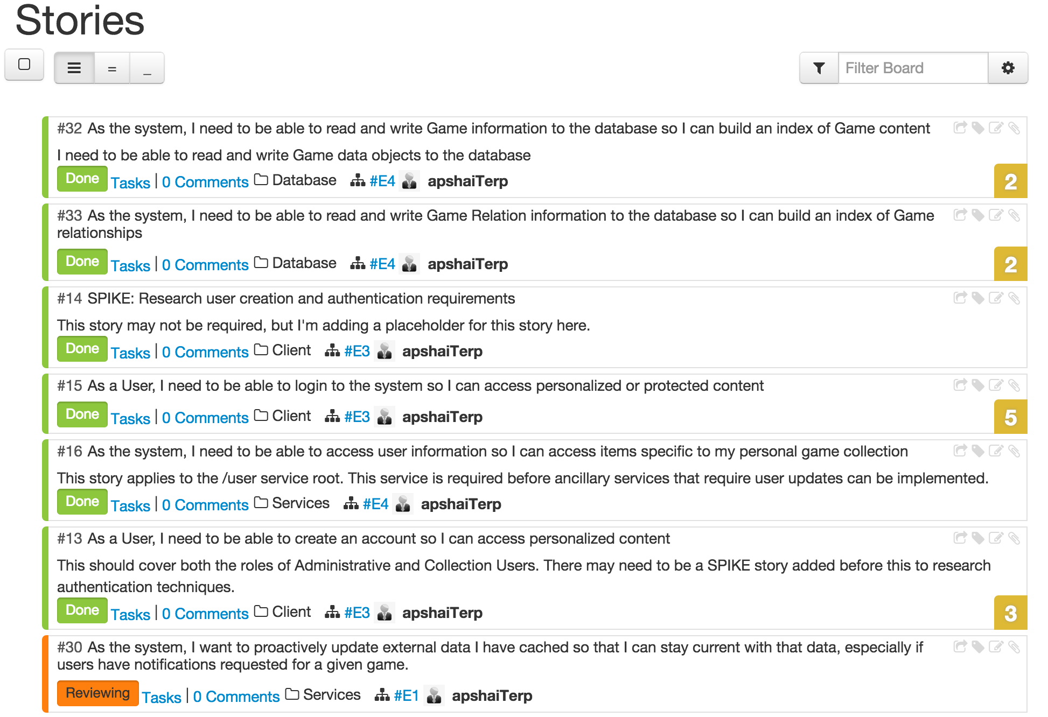

From a story perspective, 6 stories were completed, with one close to completion, and another 5 stories were begun, but not completed, which will be rolled into the third iteration.

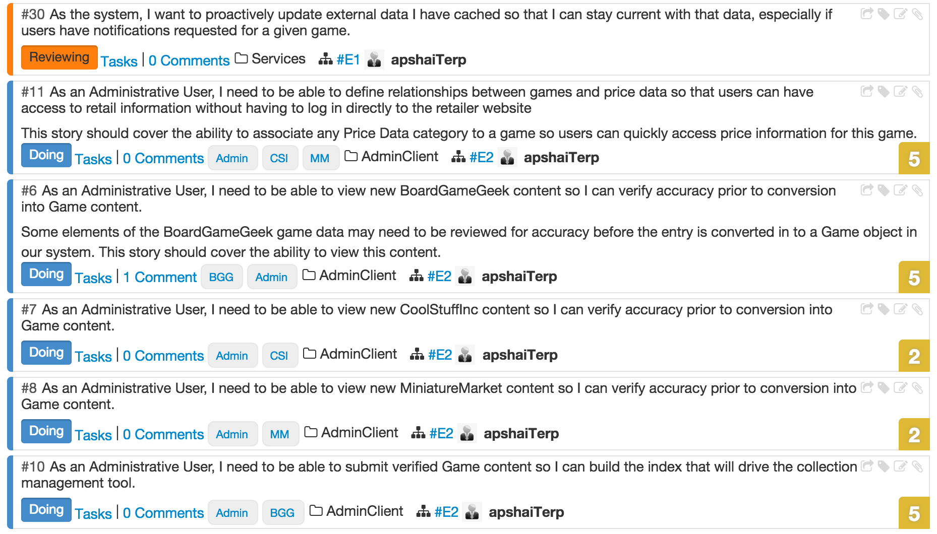

The backlog currently contains another 15 items. Many of those stories are related to the front-end HTML pages that will need to be developed that could not even be attempted without the services implementation I have been working on thus far, and I expect many of those tasks to be accomplished reasonably quickly, so at this point, I still feel confident I will be able to deliver on all the stories planned.

Finally, on the topic of design for the HTML pages, I have settled on some common elements, that I intend to use to bind the Look and Feel of my site together. There will be a navbar element at the top of the page, followed by a large visual component referred to by Bootstrap as a Jumbotron. There are also common themes of Terrapin images and a background image that all pages share that is defined in the common .css file to be shared by my HTML pages. Examples of this will be shown later in the Implementation discussion.

1. **Implementation Details**

To begin presenting what has been implemented during this iteration, I want to present some quick statistics that were generated to give an idea of progress made. Eclipse has a number of plugins that can generate code statistics driving off any number of criteria. For clarity, I will be presenting statistics in the following 4 categories: Number of Classes, Number of Tests, Total Lines of Code (TLOC), and Meaningful Lines of Code (MLOC – A measurement that ignores whitespace and commented lines).

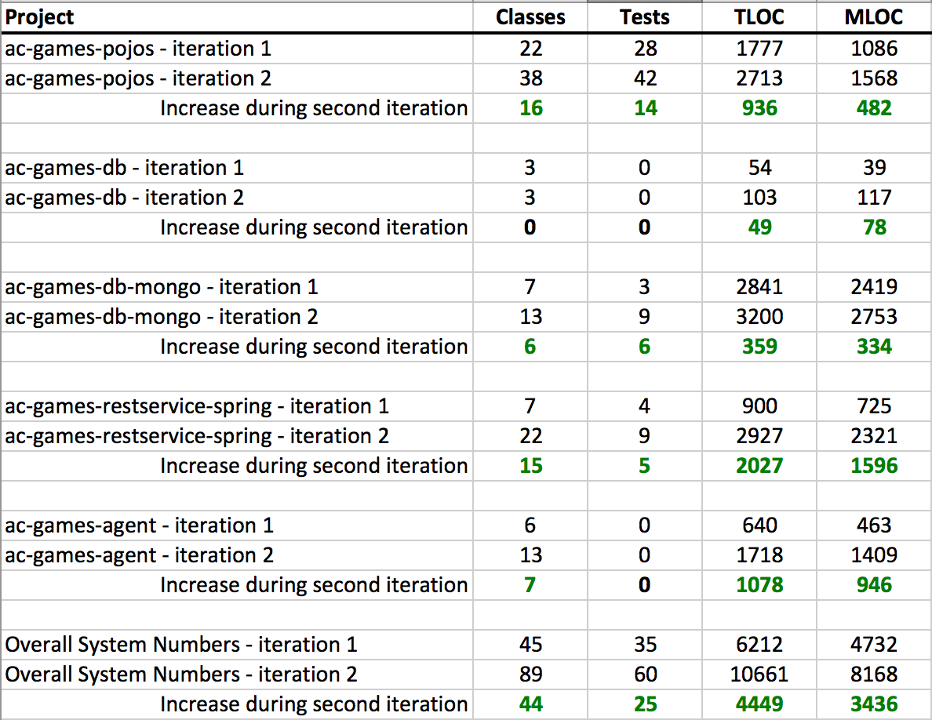

This data summary illustrates clearer than a lengthy discussion how progress has been made in all major project components. There was more work done in the Mongo space than is truly reflected in the line counts, since I was able to simplify a handful of operations by refactoring and genericizing a handful of calls.

The REST service grew the most from a raw amount of code perspective. During this iteration I implemented the following new REST service endpoints with full CRUD support (GET, PUT, POST, DELETE) unless otherwise indicated.

**/game**

**/gamereltn**

**/user**

**/collection**

**/collectionitem**

**/login** (Only supports POST for performing login operation, and PUT for updating sensitive user data)

All 6 of these new services, with their corresponding data objects and validation requirements were done this iteration.

The only major implementation detail that differs from earlier implemented services is that in some cases there are cascading effects of some data changes, for example, if I remove a User from the system, I must also remove his collection and every item in his collection from the system as well.

For reference, the code repositories for each project are listed below. All code for this release has been checked in to the Master branch of each project. Because class diagrams at this point are a little large to make inclusion in this document meaningful, they have been uploaded as part of the github project under the src/model folders.

* **ac-games-pojos** – <https://github.com/apshaiTerp/ac-games-pojos>
* **ac-games-db** – <https://github.com/apshaiTerp/ac-games-db>
* **ac-games-db-mongo** – <https://github.com/apshaiTerp/ac-games-db-mongo>
* **ac-games-restservice-spring** – <https://github.com/apshaiTerp/ac-games-restservice-spring>
* **ac-games-agent** – <https://github.com/apshaiTerp/ac-games-agent>

Finally, the last element I want to discuss is the HTML development. All development for this project is being checked in to <https://github.com/apshaiTerp/agent-site>. Included below are some screen shots from both the Standard Web view, as well as Mobile.



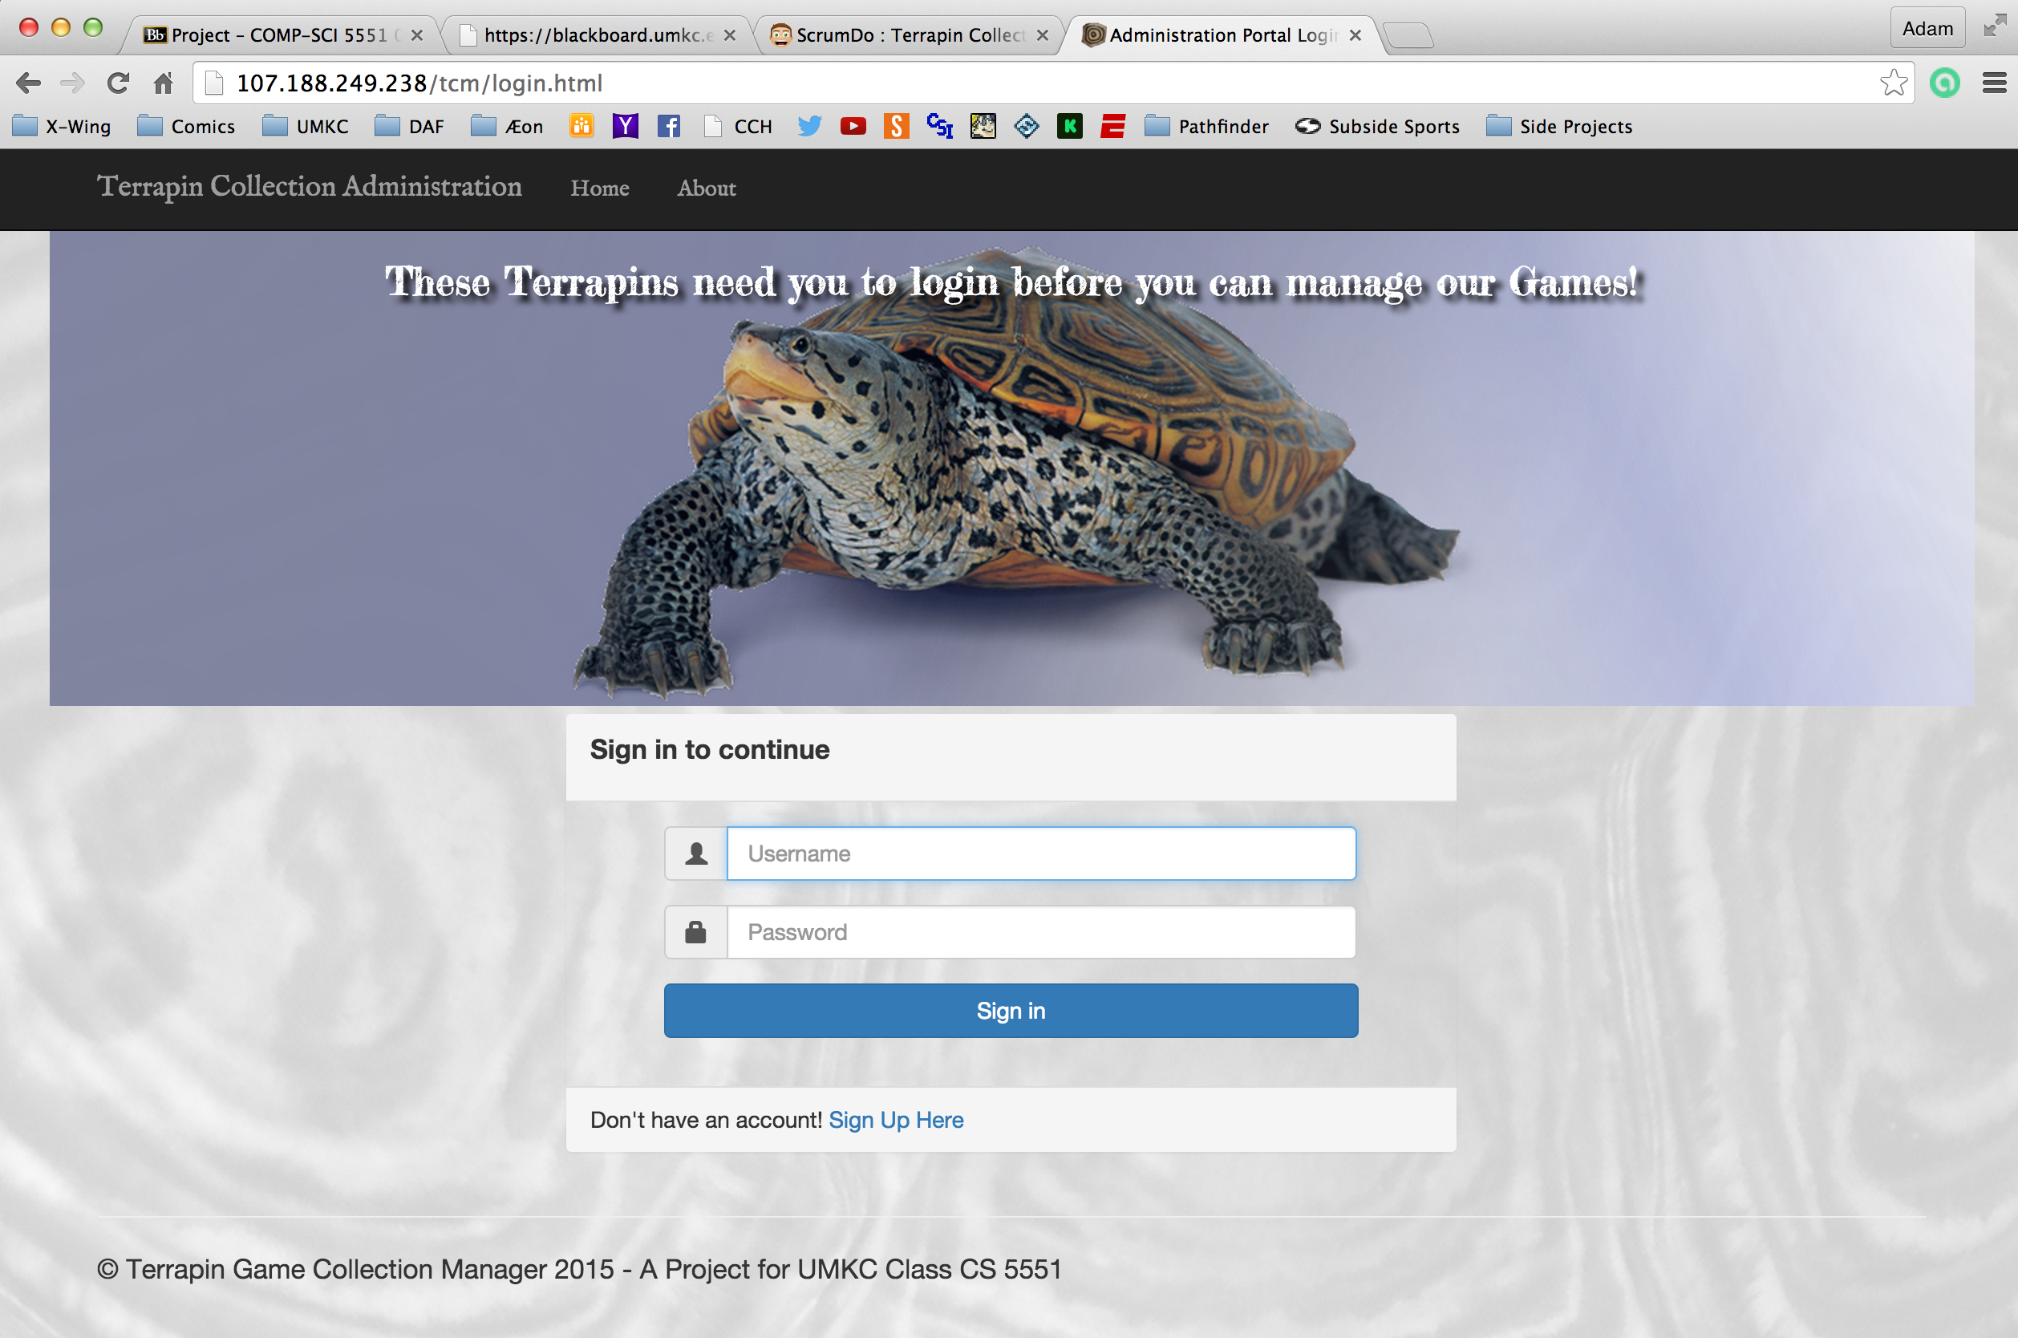

 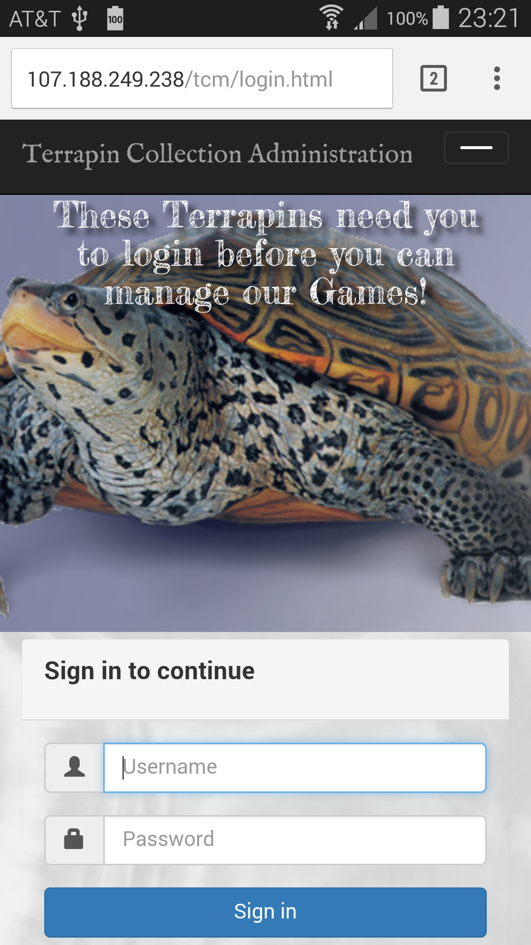

As the screen shots show, by using Bootstrap I was able to implement a responsive design that if not always as clean as the full browser version, is functional and scales all the elements appropriately.

1. **Testing**
2. **Deployment**
3. **Iteration Summary**
4. **References**

[1] – <https://github.com/apshaiTerp/cs-5551-documentation/blob/master/CS551-Project-Proposal.pdf> [2] – <https://github.com/apshaiTerp/cs-5551-documentation/blob/master/CS%205551%20Project%20Plan.pdf>

[3] – <https://github.com/apshaiTerp/cs-5551-documentation/blob/master/CS%205551%20First%20Increment%20Report.pdf>